November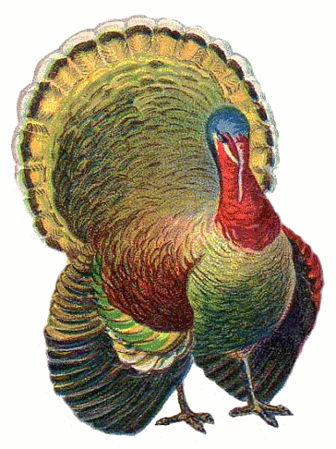
Homework Calendar
Pick one or two activities to complete each week. Color in the box as you complete each activity, and turn in your calendar on November 15th.

Name _____________________________________

Read a story with your parents. Tell the main characters and the setting. | Say your address aloud 5 times. | Choose one of your take home books to read to someone in your family. | Collect leaves and then sort them by shape, size and color.
Write the sight words to, am, the, see and little. Trace each word 4 times in a different color. If you already know how to spell those, pick 5 new sight words from your list. | Take a “Left-Right” walk. Walk from one end of your house to the other. Go into every room. Each time you turn right, say “Right!” Each time you turn left, say “Left!” Do this with an adult or older sibling. | Think about an airplane and a bird. In what ways are they alike? In what ways are they different? | Say and spell to, am, the, see and little to a grown-up. If you already know how to spell those, pick 5 new sight words from your list
Draw a picture of three things. You might draw three cats or three trucks- anything you like. Make one big, medium and small. | Take a walk outside. How many colors can you find in nature? Name them. | Put 6 objects in a row. Point to them and say which one is first, second, third, fourth, fifth, and sixth. Go higher if you can. | Make AB, AABB, and ABBC patterns using silverware. Now make up a pattern of your own.
Count as high as you can by 1s. Count as high as you can by 5s.  Count as high as you can by 10s. | Pick a newspaper or magazine page. Look for sight words. Circle them. | Write 5 different numbers on a paper. Draw or place that many items next to each number. | Complete a Contract for Reading activity.  (See our website for link)

